Zahava Gopin

WEB 335: Assignment 5.2

4/10/2023

Write a query to add a new user to the user’s collection.

Write a query to update Mozart’s email address to [mozart@me.com](mailto:mozart@me.com).

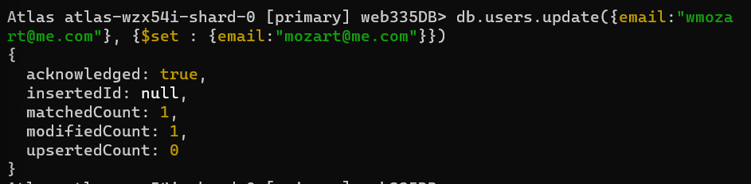

Next, write a query to prove the email address was updated

Write a query to list all documents in the user’s collection. Use projections to only display the firstName, lastName, and email fields

